

|  |
| --- |
| IBM Hack Challenge 2021  (IPL Super Predictor) |
|  |
| August 31  Team Name: Team Leo  Team Leader: Rishi Ganji(19h61a05k8) |

INTRODUCTION

# OVERVIEW

|  |
| --- |
| Since the dawn of the IPL in 2008, it has attracted viewers all around the globe. High level of uncertainty and last moment nail biters has drawn the fans to watch the matches in large numbers. Within a short period, IPL has become the highest revenue generating league of cricket. With all this, the amount of data being generated in terms of matches revenue scores etc has also become huge. Analyzing such vast amounts of data would give great insights in forecasting match results ,top scores and wicket takers etc. |
| PURPOSE  The objective of this solution is to create a dashboard that visualizes the following  capabilities and also forecasts the future results.  1.To find the team that won the most number of matches in the entire IPL.  2. To find the team that lost the most number of matches in the entire IPL.  3. Does winning a toss increase the chances of victory.  4. To find the player with the most player of the match awards.  5. To find the city that hosted the maximum number of IPL matches.  6. To find the most winning team for each season.  7. To find the on-field umpire with the maximum number of IPL matches.  8. To find the biggest victories in IPL while defending a total and while chasing a  total. 9. Which team won the most matches while batting first.  10. Which team won the most matches while batting second.  11. List of teams which have won matches by most runs cumulatively.  **LITEARTURE SURVEY**  **EXISTING PROBLEM:**  IPL Data Analysis is all about the analyzing the data that is al- ready  present in data set using data science, machine learning and python. This is an application design for the purpose of analyzing the data by fetching the attribute from the data set and predicting the future of the match and as well as of the players. This will help in the selection of the IPL team that the team should perform good and win the match. Prediction is done for anything like which player will play well in tomorrow's match, which team will win toss and even match etc. The prediction can be done with the help of the analysis on that data set collected and by displaying proper data that is useful for the future prediction.  SOLUTION:  The solution is to create a dashboard that visualizes capabilities and also forecasts the future results using the following tools we have developed the solution : IBM Cloud, IBM Cognos Analytics, IBM Watson Studio.  THEORITICAL ANALYSIS  Block Diagram: |

HARDWARE AND SOFTWARE

REQUIREMENTS

1)IBM Cloud

2)IBM Cognos Analytics

3)IBM Watson Studio.

RESULTS

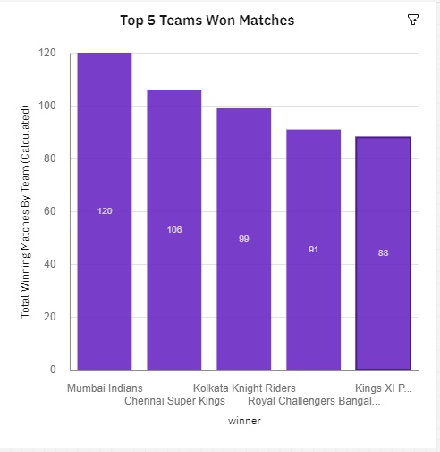

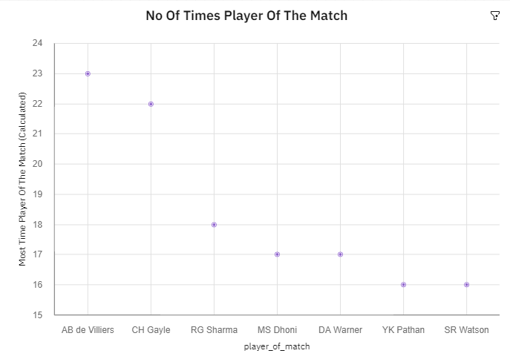

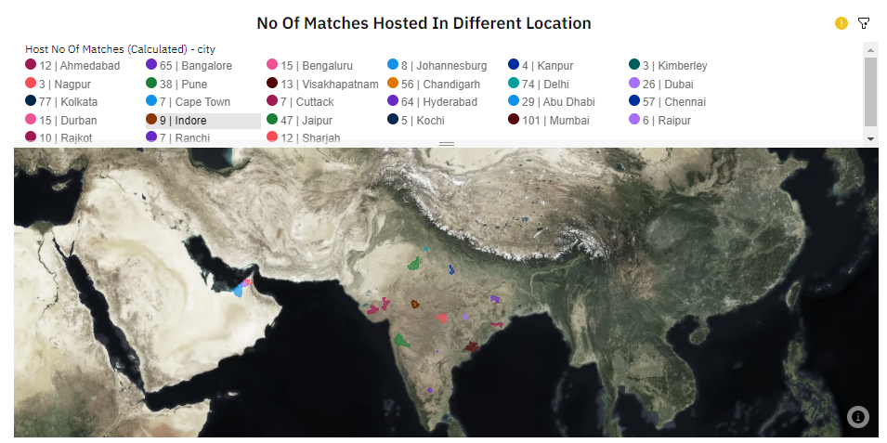

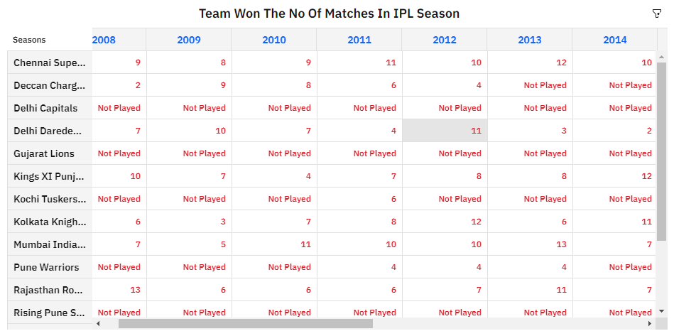

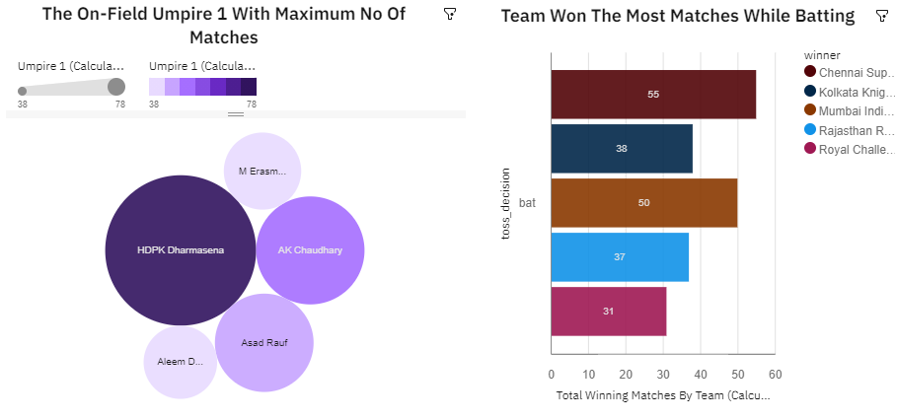

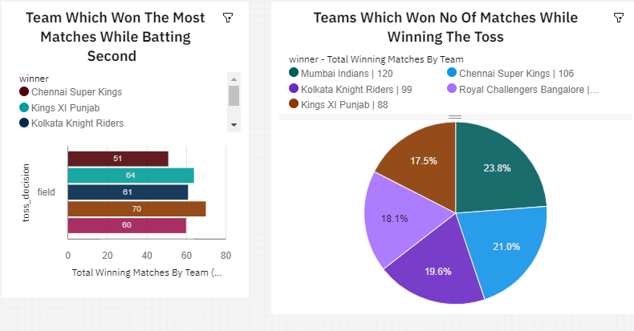

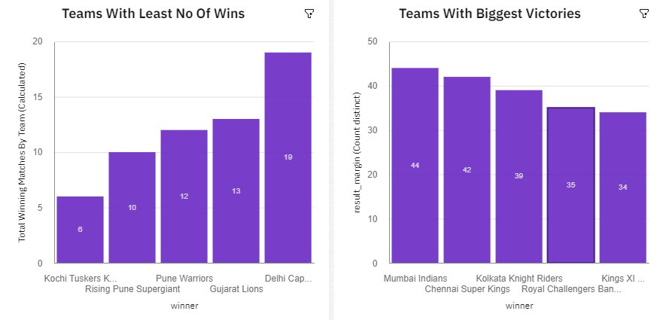

ADVANTAGES OF THE PROPOSED

SOLUTION

To provide the statistical analysis of players based on different

characteristics. To predict the performance of a team

depending on individual player statistics. To successfully predict the outcome of IPL matches.

APPLICATION

The main objective of sports prediction is to improve team

performance and enhance the chances of winning the game. The value of a win takes on different forms like trickles down to the fans filling the stadium seats, television contracts, fan store merchandise, parking, concessions, sponsorships, enrollment and retention.

CONCLUSION

This work aims at understanding the dataset of past 12 years

history of the IPL data. It helps to understand machine learning algorithms working principal and their implementation. It creates the Model and Training dataset and helps to predict with the help of the model created. The model classifies the data and compares the results. It takes into consideration the measures accuracy, error rate, precision, recall, sensitivity and specificity. This work focuses on exploring IPL data and presenting its insights as graphical representation and comparative analysis. By making use of this, Indian Premier League and the fan followers can take decisions on the team’s performance and predict the trophy winners that will lead to success in future.

FUTURE SCOPE

The implementation tools Anaconda navigator, Jupiter,

Random Forest is observed to be the best accurate classifier with 89.15% to predict the best player performance. This knowledge will be used in future to predict the winning teams for the next series IPL matches. Hence using this prediction, the best team can be formed.

BIBLIOGRAPHY

*IBM

*SmartInternz

*www.google.com

*www.wikipedia.com